FINIKAS HOTEL
Pyrgaki, Naxos Island
T: +30 22850 75230
F: + 3022850 75025
E: info@finikashotel.gr
www.finikashotel.gr
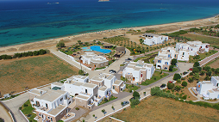

PLAZA BEACH HOTEL
Plaka, Naxos Island 84 300 |
T: +30 22850 29400-9
F: +30 22850 29241
E: info@plazabeachhotel.gr
www.plazabeachhotel.gr

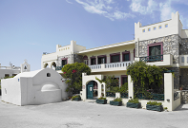

APOLLON HOTEL
Old town (Chora), Naxos Island 84 300 |
T: +30 22850 26801-2
F: +30 22850 25200
E: info@apollonhotel-naxos.gr
www.apollonhotel-naxos.gr

