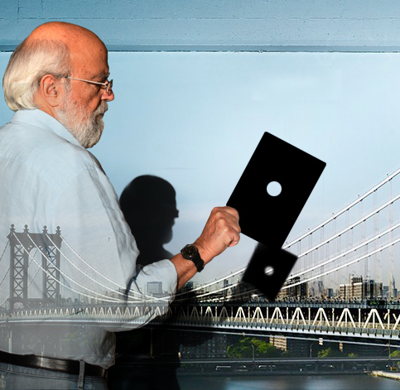  
**Costis ANTONIADIS**

Born in Athens in 1949, Costis Antoniadis studied Physics at the Aristotelion University of Thessaloniki and subsequently photography at the Institut Francais de la Photographie in Paris. He is a founding member of the Photography Centre of Athens (1979-2004) and in 1985 was appointed professor at the Department of Photography and Audiovisual Arts of TEI, Athens. For many years, he has been working as curator and organizer of numerous exhibitions for the Photography Centre, the International Month of Photography, the French Institute, the Benaki Museum in Athens. In 2003 he was appointed as Director of the Museum of Photography at Thessalonica and from 2006 he works as a freelance curator. Since 1979 he has been publishing, and continues to publish articles on critical theory in numerous photographic and visual art reviews. He also exhibits in Greece and abroad, and many of his works feature in individual and national collections.

[www.costisantoniadis.gr](http://www.costisantoniadis.gr)

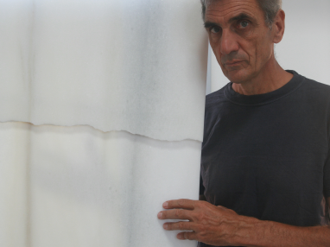

**Ingbert BRUNK**

Ingbert Brunk was born in Dannenberg, North Germany, in 1960. He studied sculpture at the Berlin School of Fine Arts (1980-1985) and, still a student, he visited Greece where he became familiar with the unique translucence and variegation of Naxian marble. He settled in Naxos as soon as he graduated and, since then, for 35 years, has been Naxos-based, working exclusively with this medium. His creative springboard is often the marble itself, which, he claims, “constitutes the transmutation of light into matter.”  
His work stems from the notion that art sets up the circumstances that allow us to enter other mental and spiritual states. He sculpts day in, day out, and feels that “only in this very place, in the heart of the Aegean under the Cycladic light” is creative work worth pursuing.  
Austerity of form, perfection of the building process, as well as bringing out the unique colourfulness and the crystalline transparency of marble have been his steadfast endeavours.   
Throughout his creative life, he has been negotiating and processing the concept of time from an existential perspective. The marble boats, the crosses, the movements, the spirals, point to an attempt to establish a dialogue with the circularity of time, its relativity, the relentlessness it entails.  
For over 30 years, he has participated in a number of exhibitions and sculpture symposia across Europe.  
Over the past decade, he has lived, worked and displayed his works in his studio at Azalas, on the east coast of Naxos, amidst a timeless landscape seemingly untouched by evolution, where the ancient Cycladic islanders lived and created.